Pupil premium strategy statement 2023/24

This statement details our school’s use of pupil premium funding to help improve the attainment of our disadvantaged pupils.

It outlines our pupil premium strategy, how we intend to spend the funding in this academic year and the effect that last year’s spending of pupil premium had within our school.

School overview
Detail | Data
School name | Powerstock CE VA Primary
Number of pupils in school | 58
Proportion (%) of pupil premium eligible pupils | 12%
Academic year/years that our current pupil premium strategy plan covers (3 year plans are recommended) | 2021-2024
Date this statement was published | October 2023
Date on which it will be reviewed | October 2024
Statement authorised by | Interim Head
Pupil premium lead | Lisa Crew
Governor / Trustee lead | David Bligh

Funding overview
Detail | Amount
Pupil premium funding allocation this academic year | £13,095
Recovery premium funding allocation this academic year | £2,000
Pupil premium funding carried forward from previous years (enter £0 if not applicable) | £0
Total budget for this academic year  If your school is an academy in a trust that pools this funding, state the amount available to your school this academic year | £15,095

Part A: Pupil premium strategy plan

Statement of intent
Our intention is that all pupils, irrespective of their background or the challenges they face, make good progress and achieve high attainment across all subject areas. The focus of our pupil premium strategy is to support disadvantaged pupils to achieve that goal, including progress for those who are already high attainers.
We will consider the challenges faced by vulnerable pupils, such as those who have a social worker and young carers. The activity we have outlined in this statement is also intended to support their needs, regardless of whether they are disadvantaged or not.
High-quality/Quality First teaching is at the heart of our approach, with a focus on areas in which disadvantaged pupils require the most support. This is proven to have the greatest impact on closing the disadvantage attainment gap and at the same time will benefit the non-disadvantaged pupils in our school. Implicit in the intended outcomes detailed below, is the intention that non-disadvantaged pupils’ attainment will be sustained and improved alongside progress for their disadvantaged peers.
Our approach will be responsive to common challenges and individual needs, rooted in robust diagnostic assessment, not assumptions about the impact of disadvantage. The approaches we have adopted complement each other to help pupils excel. To ensure they are effective we will:
- ensure disadvantaged pupils are challenged in the work that they’re set
- act early to intervene at the point need is identified
- adopt a whole school approach in which all staff take responsibility for disadvantaged pupils’ outcomes and raise expectations of what they can achieve.
- Work closely with link governors to review and update implementation, wellbeing of pupils and staff and impact of actions.

Challenges

This details the key challenges to achievement that we have identified among our disadvantaged pupils.
Challenge number | Detail of challenge
1 | Speech and Language difficulties leading to phonics acquisition delay.
2 | Poor attendance
3 | Social and emotional/mental health issues. General wellbeing
4 | Core Subject low attainment
5 | Parental Engagement

Intended outcomes
This explains the outcomes we are aiming for by the end of our current strategy plan, and how we will measure whether they have been achieved.
Intended outcome | Success criteria
Improved oral language skills and vocabulary among disadvantaged pupils. | Assessments and observations (including NELI screening) indicate significantly improved oral language among disadvantaged pupils. This is evident when triangulated with other sources of evidence, including engagement in lessons, book scrutiny and ongoing formative assessment.
Improved reading attainment among disadvantaged pupils. | KS2 reading outcomes in 2024/25 show that attainment/progress in line with non PP peers.
Improved maths attainment for disadvantaged pupils at the end of KS2. | KS2 maths outcomes in 2024/25 show that attainment/progress in line with non PP peers.
To achieve and sustain improved wellbeing for all pupils in our school, particularly our disadvantaged pupils. | Sustained high levels of wellbeing from 2021/25 demonstrated by:  - pupil survey, student and parent surveys and teacher observations  - Holistic Picture indicates improvement in 10 areas of focus. This will be supported by focus case studies.  - a increase in participation in enrichment activities, particularly among disadvantaged pupils
To achieve and sustain improved attendance for all pupils, particularly our disadvantaged pupils through parental support. | Sustained improvement in attendance by end 2024 demonstrated by:  - the overall absence rate for all pupils being no more than 10%, and the attendance gap between disadvantaged pupils and their non-disadvantaged peers being reduced by 5%..

Activity in this academic year
This details how we intend to spend our pupil premium (and recovery premium funding) this academic year to address the challenges listed above.

Teaching (for example, CPD, recruitment and retention)
Budgeted cost: £ 4,660
Activity | Evidence that supports this approach | Challenge number(s) addressed
Embedding dialogic activities across the school curriculum. These can support pupils to articulate key ideas, consolidate understanding and extend vocabulary.  Aspirational language; P4C reviewed in Spring 2022.  Oracy 21, part of our Reading Actions for 22/23.  New Literacy Tree resource to bring high quality text work to all pupils. | There is a strong evidence base that suggests oral language interventions, including dialogic activities such as high-quality classroom discussion, are inexpensive to implement with high impacts on reading:  Oral language interventions | Toolkit Strand | Education Endowment Foundation | EEF | 1
Purchase of a DfE validated Systematic Synthetic Phonics programme to secure stronger phonics teaching for all pupils:  Floppy’s Phonics and Read,Write, Inc for any year group across school | Phonics approaches have a strong evidence base that indicates a positive impact on the accuracy of word reading (though not necessarily comprehension), particularly for disadvantaged pupils:  Phonics | Toolkit Strand | Education Endowment Foundation | EEF | 1,4
Improve the quality of social and emotional mental health SEMHs learning.  ELSA dedicated three afternoons a week.  Mental Health Champion training (HT – November and January 2022/23  Five to Thrive training – all staff 2022 Autumn | SEMH learning approaches will be embedded into routine educational practices and supported by professional development and training for staff. There is extensive evidence associating childhood social and emotional skills with improved outcomes at school and in later life (e.g., improved academic performance, attitudes, behaviour and relationships with peers): | 3
Supporting CPD for teaching and support staff | Supporting high quality teaching is pivotal in improving children’s outcomes. Research tells us that high quality teaching can narrow the disadvantage gap. It is therefore hugely encouraging to see a host of new initiatives and reforms that recognise the importance of teacher quality such as the Early Career Framework and the new National Professional Qualifications. These exemplify a growing consensus that promoting effective professional development (PD) plays a crucial role in improving classroom practice and pupil outcomes | 1,4
Enhancement of our maths teaching and curriculum planning in line with DfE and EEF guidance through Collaboration Maths Hub work.  We will fund teacher release time to embed key elements of guidance in school and to access Maths Hub resources and CPD (including Teaching for Mastery training). | The DfE non-statutory guidance has been produced in conjunction with the National Centre for Excellence in the Teaching of Mathematics, drawing on evidence-based approaches:  Maths_guidance_KS_1_and_2.pdf (publishing.service.gov.uk)  The EEF guidance is based on a range of the best available evidence:  Improving Mathematics in Key Stages 2 and 3 | 4

Targeted academic support (for example, tutoring, one-to-one support structured interventions)
Budgeted cost: £ 5,000
Activity | Evidence that supports this approach | Challenge number(s) addressed
Additional phase phonics sessions targeted at disadvantaged pupils who require further phonics support.  This work is supported by our work with the Collaboration and Somerset Literacy Network. | Phonics approaches have a strong evidence base indicating a positive impact on pupils, particularly from disadvantaged backgrounds. Targeted phonics interventions have been shown to be more effective when delivered as regular sessions over a period up to 12 weeks:  Phonics | Toolkit Strand | Education Endowment Foundation | EEF | 1,4
New HLTA to implement targeted intervention across school. | Tuition targeted at specific needs and knowledge gaps can be an effective method to support low attaining pupils or those falling behind, both one-to-one:  One to one tuition | EEF (educationendowmentfoundation.org.uk)  And in small groups:  Small group tuition | Toolkit Strand | Education Endowment Foundation | EEF | 4,5

Wider strategies (for example, related to attendance, behaviour, wellbeing)
Budgeted cost: £1,150 Forest School ELSA as before
Activity | Evidence that supports this approach | Challenge number(s) addressed
Forest School every other week for each class  Mindfulness  ELSA sessions timetabled | Forest School provides many benefits for all children seeing improvements in mental health and attitudes to learning:  https://www.forestresearch.gov.uk/research/forest-schools-impact-on-young-children-in-england-and-wales/  Mindfulness is embedded in whole school practice:  https://mindfulnessinschools.org/wp-content/uploads/2013/02/MiSP-Research-Summary-2012.pdf | 2,3
Extra curricular activities/clubs  After school clubs for enrichment eg. Cooking/gardening club. Afterschool club craft activities. | After school clubs for enrichment eg. Cooking/gardening club. Afterschool club craft activities.
Volunteer readers to hear children read at least twice a week | Phonics improves the accuracy of the child’s reading but not necessarily their 1 comprehension. It is important that children are successful in making progress in all aspects of reading including comprehension, the development of vocabulary through reading quality texts. | 1,2,3,4
Improving parental engagement | The EEF reports that - “Parents play a crucial role in supporting their children’s learning, and levels of parental engagement are consistently associated with better academic outcomes. Evidence from our Teaching and Learning Toolkit suggests that effective parental engagement can lead to learning gains of +4 months over the course of a year. There are also higher impact for pupils with lower attainment saying “practical strategies with tips, support and resources to assist learning at home may be more beneficial to pupil outcomes.” | 3,4,5
Assigning a transition mentor at key moments | It is well documented that transitions are very important for children and can be a challenging and anxiety-provoking time, particularly when the child is vulnerable or has special educational needs and/or a disability that require understanding and support over the transition. Our Educational Psychologist service emphasise the need for support during transitions for our vulnerable children. To ensure smooth transition we employ a mentor to work with the children in our school. | 3,5
Assistance with school uniform/kits | EEF recognise that school uniform assistance is thought to complement the development and support of a whole school culture and approach, which in turn may assist pupil discipline and motivation. However although there is little evidence of it improving progress it has been noted that children from poorer socio economic backgrounds benefit from this strategy. The school supports this with a second hand uniform hub run by the PTA. | 3,5
Assistance with school trip/sundries | Contributions are offered to each parent in the event of a school trip donation requested. | 3,5

Part B: Review of outcomes in the previous academic year

Pupil premium strategy outcomes
This details the impact that our pupil premium activity had on pupils in the 2022 to 2023 academic year.
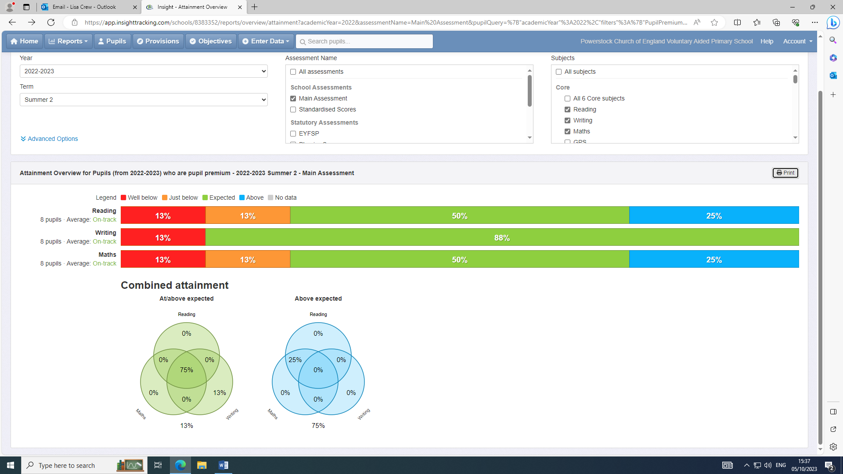

Externally provided programmes
Please include the names of any non-DfE programmes that you purchased in the previous academic year. This will help the Department for Education identify which ones are popular in England
Programme | Provider

Service pupil premium funding (optional)
For schools that receive this funding, you may wish to provide the following information:
Measure | Details
How did you spend your service pupil premium allocation last academic year? | Same strategies as Pupil premium.
What was the impact of that spending on service pupil premium eligible pupils? | Please see strategy outcomes on previous page.

Further information (optional)

