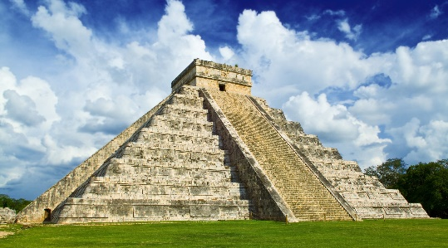 **The Mayans**

**History**

**The key question we will be exploring will be ‘Why did the ancient Maya change the way they lived?’ Through a series of questions, we will find out about the Mayans who lived 300-900AD and 8 million of whom still live in the Mexican region today.**

**Geography**

**Mountains feature in the Mayan landscape and so we will be studying the key question ‘Why are mountains so important?’ This will lead to focus on the structure of the Earth’s crust, plate tectonics as well as human interaction with mountains.**

**Literacy**

**Our literacy tree texts are based in the Mayan culture (Rainplayer), fairytale narratives (Firebird) and fairytale reworkings (The Sleeper and the Spindle). All texts will give opportunities for extending understanding and use of grammar such as modal verbs, subjunctive tense, expanded noun phrases etc and provide an opportunity to write letters, diaries, newspaper reports and new story chapters. We will continue to work through the spelling units. The class book will continue with The Railway Children – a classic!**

**Science**

**Animals including humans is our focus this term. This will focus on human and animal lifecycles and finding out about the different stages within these cycles. The stages of human development will also be studied with a particular focus on puberty.**

**DT**

**We will study how automata are created (linking with last term’s Hugo Cabret book) and then try to make our own based on animals found in central America.**

**Art**

**We will be creating sculptures using Modroc (again, linking to last term’s science work on irreversible changes).**

**Music**

**We will continue with our recorder playing as we have begun a good foundation of 3 notes previously. Our learning will enable us to play notes with 2 hands.**

**RE**

**The 1st unit will find out the answer to the question ‘How can Brahman be everywhere and in everything?’ This is a Hindu study and will be followed by a Christian unit as we lead into Easter with the question: ‘What do Christians believe Jesus did to save Human Beings?**

**PSHE**

**Through discussion, we will be exploring how to keep safe, exploring dilemmas and risk assessing a variety of scenarios. We will also focus on rights and respect.**

**French**

**Our focus will be on asking questions and responding to them whilst extending our vocabulary about ourselves, how we look, our families and where we live.**

**PE**

**Throughout the whole term, we will be continuing swimming lessons and developing our stamina, skills and water safety.**

**Computing**

**Video production and the different ways of doing this will be a key feature of our learning in computing this term.**

**Maths**

**Continuing the White Rose work, we will continue to develop our manipulation of number in a wide range of topics including ratio, fractions, decimals, perimeter, area and statistics.**