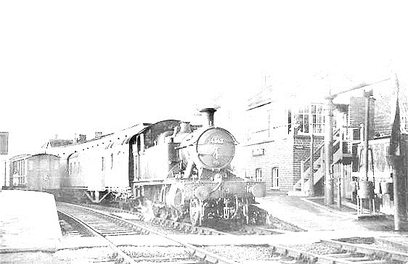
Railways – making Connections; we’re all in this together
This term, will be a local history study of the railways and how aspects of the national picture affected our local area. We will focus on the pioneering and tenacious work of others, reflecting on these elements in our own lives as well as studying groups of people & individuals. We plan to visit Bridport Museum & possibly travel on a steam train.
History – we will study the invention of the power of steam, the creation of railways & their effect on people, places & the economy both nationally & locally. We will look at the demise of railways after the Beeching Report.

Geography – will link with the historical aspects & include population studies, city growth creations, how land use has changed & the main local land use & trade over time. Map work will include symbols, contour lines & changes over time.

DT – will continue the study of land use as we learn different embroidery stitches to create a Powerstock landscape.

PSHE – we will focus on the school value of perseverance & the SCARF units of ‘Me & My Relationships’ & ‘Valuing Differences. We will study the suffragette movement & The Bridport Railway Company too.

English – using the Literacy Tree books, we will continue the theme of journeys & migration by reading Windrush Cild. We will also look at persuasive writing as we read Suffragette- The Battle For Equality. We w ill also enjoy The Invention of Hugo and write our own biographies. We will study some poetry & produce some performance poems.

Music – we will link performance poetry with topic based songs but the main thrust of music will be playing an instrument and beginning/continuing to read music.

Art – painting will be the skill we focus on and this will be heavily influenced by the artist Constable.

Science – we will tie in the work on steam trains with forces as well as exploring the properties of materials and their reversible or irreversible changes.
French – we will make some links with PSHE & History as we learn vocabulary for transport and parts of the body, learning about masculine and feminine nouns as well as knfinitive verbs & the present tense.

Computing – we will follow the Teach Computing programme about databases and link with Science.
RE – we will focus on 2 questions: what is the best way for Hindus to show commitment to God? & Was Jesus the Messiah? We will also explore some philosophical questions throughout the term.

Maths – We will focus on the 4 number processes and their application to more challenging questions and scenarios.

